**What is Gas Limit?**

Ethereum prevents transaction spamming and rewards miners by charging a gas fee on transactions. Each block contains a maximum amount of gas that can be collected from transactions which also defines the maximum block size.

This same gas limit could be set as a configuration parameter. In the long term, the block gas limit approaches a target gas limit which can also be set as a configuration parameter.

The theoretical maximum transactions per second (TPS) can be calculated using the following equation:



GasLimit = Block gas limit

TxGas = gas needed to compute the simplest transaction

Source: <https://blog.coinfabrik.com/on-ethereum-performance-evaluation-using-poa/>

**Block Size and Block Interval must satisfy:**

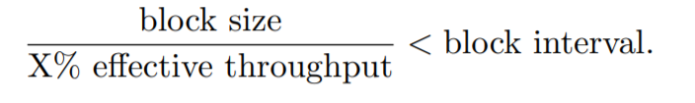

Source: <https://fc16.ifca.ai/bitcoin/papers/CDE+16.pdf>

Summary:

As seen in the above relation, Block Interval and Throughput are directly proportional to each other. It means that the effective throughput decreases when the block interval is decreased.

Consider an example:

A blockchain with 1GB blocks every 10 minutes.

In order for nodes on the network to stay in sync with the chain, they will need to download and verify the validity of 1GB worth of block data every 10 mins.

Any node(s) which cannot do this will decrease the effective throughput of the network.

Now, consider what happens if you decrease the block interval to 1 min.

Suddenly, a lot of nodes that could download and process that data within 10 mins will no longer be able to keep up with the rest of the network, since they now only have 1 min to do the same.

Therefore, our effective throughput has decreased, since a much smaller percent of nodes will be able to engage and contribute to the network.

Source: <https://bitcoin.stackexchange.com/questions/76203/how-are-block-interval-block-size-and-effective-throughput-related>

Paper: **Block Gas Limits vs. Transactional Throughput: A performance analysis of the Ubiq platform.**

I am mentioning important points from the paper which are relevant for us, for faster understanding.

The above paper explains (in short) the relation between gas limit and throughput as:

“The higher the gas limit, the larger the block.

The larger the block, the longer the block will take to propagate throughout the network and consequentially results in lower transaction throughput. “

The paper defines total transactions as “number of transactions included within the current block”.

It defines block time as “time difference between the current block and parent block”.

Block gas usage is defined as “gas consumed in processing transactions for the current block”.

It also defines **difficulty** as “total mining difficulty up to the current block.” (something we did not consider)

The paper is comparing the performances of Ubiq and Ethereum.

In this case, they are benchmarking both blockchain systems in steps of following gas limits (in millions): 4,8,16,20,40,80.

The did the following 3 experiments:

1. Block time vs block number (changing gas limit as mentioned above)
2. Difficulty level vs block number (changing gas limit as mentioned above)
3. Gas limit vs block number (changing gas limit as mentioned above)

This is the result that they achieved for Ethereum:

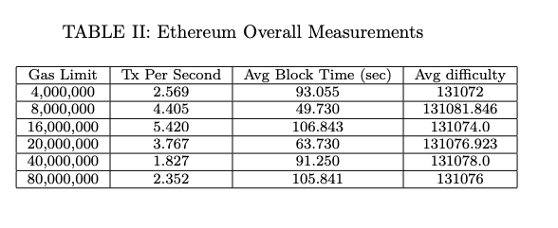

Source: <https://www.whiteblock.io/wp-content/uploads/2019/07/ubiq-report.pdf>

Summary:

The relation between gas limit and throughput is non-linear.

The optimal throughput can be figured out by plotting gas limit vs throughput for a particular blockchain system.

An interesting parameter mentioned in this paper is the **difficulty level.** It means how difficult is it to find the hash of a block.

Another parameter that affects throughput is **Latency**.

Based on this paper, my understanding is that we can find the optimal throughput by changing the gas limit. However, in my opinion, we should also consider the Difficulty Level to verify the optimal throughput reading that we find.   
  
The following article is a good reference: <https://hackernoon.com/how-to-reduce-block-difficulty-in-ethereum-private-testnet-2ad505609e82>